**Day 2 Hackathon:**

Transitioning to Technical Planning:

Frontend Requirements:

1. Firework: Next JS
2. Responsive design for Mobile, Tablet & Laptop by using Features Navigation, Grid Layouts, Search and Filters, Content Priority, Images in Tailwind CSS.
3. Essential Pages which I use in my Website Home, About us, Products, Contact us. And Products child pages, Product Category, Add to Chart, Order Confirmation.

Backend Requirements:

1. Sanity use for Real-time collaboration and flexible content modeling, Studio (admin panel) can be hosted or integrated into apps, Offers a generous free tier for small projects.

Third Party API:

1. Shipment Tracking using DHL, TCS, Leopard.
2. Payment Gateway: EasyPaisa, Jazz Cash, HBL Connect.
3. Email Services: Cloud Server.

**Design System Architecture**

Work Flow Chart

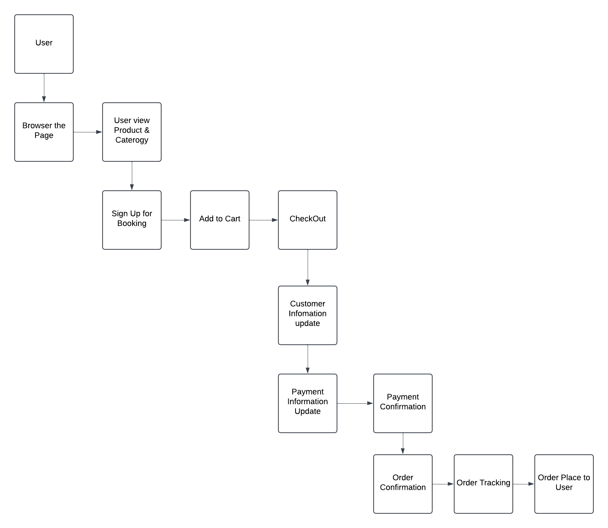

Work Flow details

1. User visit Rental Website and send request to browser.
2. API received the request and send to Sanity CMS getting data.
3. Sanity CMS send the Product data to API and API send the result to User.
4. User view the Page and Select the product which received from Sanity.
5. User add the Product in ADD to Cart and send request to API and API send request to Data Base and Post order.
6. Data Base request to API for collect customer data and information for Post Order to address.
7. API ask request to User to provide information, payment process for post the order and tracking shipment.
8. If any details of customer provide wrongly API send error to User as failure.
9. **Plan API requirements**
10. Endpoint name: /Products

* **Method:** GET
* **Description:** Fetch all products from Sanity
* **Response:** Product (ID, Name, Price, Description, Image, Rating, Category, Stock).

1. **Endpoint name:** /Customers

* **Method:** POST
* **Description:** Get customer’s data and add it in sanity
* **Response:** Customer (ID, Name, Email, Phone, Address).

1. **Endpoint name:** /Orders

* **Method:** POST
* **Description:** Create a new order in Sanity.
* **Response:** Order (ID, Customer ID, Order, Date, Item, Amount, Status)

1. **Sanity Data Schema for all endpoints:**
2. **Products:**

export default

{ name: 'product', type: 'document', fields: [

{ name: 'id', type: 'number', title: 'Product Id' }

{ name: 'name', type: 'string', title: 'Product Name' },

{ name: 'price', type: 'number', title: 'Price' },

{ name: 'Description', type: 'string', title: 'Description' }

{ name: 'Image', type: 'string', title: 'Image' }

{ name: 'Rating', type: 'number', title: 'Rating' }

{ name: 'Category', type: 'string', title: 'Category' }

{{ name: 'Stock', type: 'number', title: 'Stock' }

]

1. **Order:**

export default

{ name: 'order', type: 'document', fields: [

{ name: 'id', type: 'number', title: 'Ordr Id' }

{ name: 'customerId', type: 'number', title: 'Customer Id' },

{ name: 'date', type: 'date’, title: 'Order Date' },

{ name: 'amount', type: 'number', title: 'Total Amount' }

{ name: 'productID', type: 'number', title: 'Product Id’},

{ name: 'address', type: 'string', title: 'Delivery Address’},

]

1. **Orders:**

export default

{ name: 'customer', type: 'document', fields: [

{ name: 'id', type: 'number', title: 'Customer Id' }

{ name: 'name', type: 'string', title: 'Customer Name' },

{ name: 'email', type: 'string’, title: 'Email' },

{ name: 'phone', type: 'number', title: 'Phone Number' }

{ name: 'address', type: 'string', title: 'Address’},

]